**Unit 9: Exponential**

**Lesson 3:**

**Linear vs. Exponential Systems & Linear –Quadratic & Quad/ Exponential.**

**Objectives:**

* I can use the calculator to examine and analyze functions.
* I can solve systems of linear, exponential and quadratic functions in real-life applications graphically.

**Agenda:**

* Do Now:
* Quadratics
* Guided practice
  + Linear vs. Exponential
* Practice



**Focus Questions:**

* How can I use the calculator to graph functions in real life applications?
* How can I use the calculator to find a table of values of two functions?
* How can I use the calculator to find the output for a specific input in two functions?
* How can I use the calculator to find POI?

**Vocabulary:**

* System of equations
* **Point of Intersection (POI)**

**Homework: HW 9-3: Systems**

**Quiz next block on lesson 1 and lesson 2**

**Warm up: Work with a partner.**

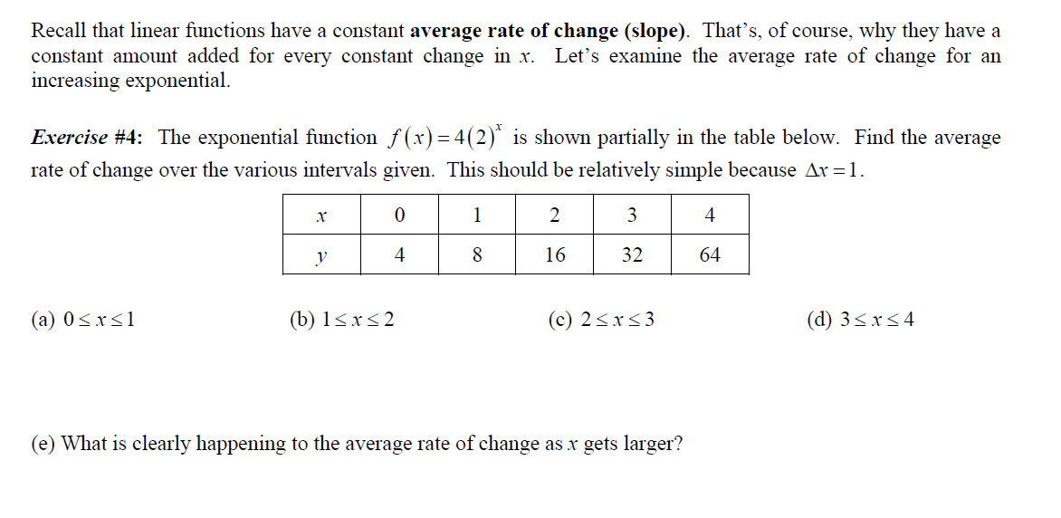

1. A population of fruit flies is growing at a constant rate of 6% per hour. The population at t = 0, with 28 flies.
2. Find a formula that models the population P, as a function of the time in hours t & Identify the parameters of the scenario:
3. What is the value of P(24), explain the meaning of the output in the context of the problem.

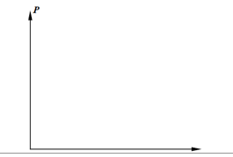

1. State the range of the population function over the domain interval $0≤t≤24$
2. Using the graphing calculator, sketch a graph of this function over the interval

$$0≤t≤24 and 0≤P≤120$$

**Notes: Day 3: Systems of Equations graphically:**

A system of equations is a set of two or more equations with the same variables, graphed in the same coordinate plane.

1) Graph the following exponential functions $f\left(x\right)= 3^{x}+3$& $g\left(x\right)=3^{x}$ b. How is f(x) differ than g(X)?



2)A company is considering building a manufacturing plant. They determine the weekly production cost at site *A* to be $A\left(x\right)= 3x^{2}$ while the production cost at site *B* is , where *x* represents the number of products, *in hundreds,* and *A*(*x*) and *B*(*x*) are the production costs, *in hundreds of dollars*

1. Graph the production cost functions on the set of axes below and label them site *A* and site *B*.
2. State the positive value(s) of x for which the production costs at the two sites are equal. Explain how you determined your answer.
3. If the company plans on manufacturing 20 products per week, which site should they use? Justify your answer.

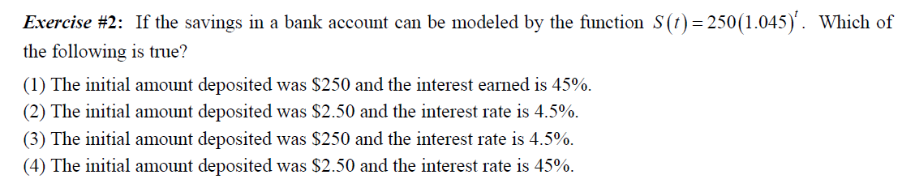

**Homework:9-3 Name: _______ Date: _____**

1. Let $f\left(x\right)=-{.5x}^{2}$ and $g\left(x\right)=2x-4$. On the set of axes below, draw the graphs of both functions. Then determine and state all values of x for which f(x) = g(x).



2) A manufacturing plant. They determine the weekly production cost at site *A* to be

while the production cost at site *B* is , where *x* represents the number of products, *in hundreds,* and *A*(*x*) and *B*(*x*) are the production costs, *in hundreds of dollars*.

1. Graph the production cost functions on the set of axes below and label them site A and site B. Include a table of values.
2. State the positive value(s) of x for which the production costs at the two sites are equal. Explain how you determined your answer.

3Use a graphing calculator to graph the function . Does this function model exponential growth or decay? Justify your answer**. Over integral [ 0, 3]**



4

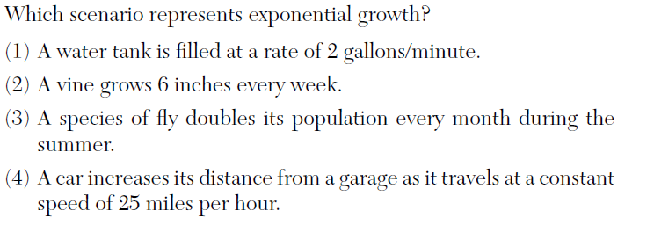

**List the four major formulas that you must make flash cards for: Hint☺**

|  |  |
| --- | --- |
| Rate of change | Growth and Decay |
| Simple interest | Compound interest |

Extras:

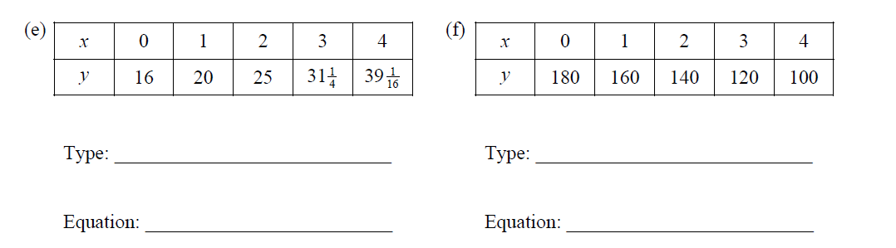

2) **Systems of Quadratic and Exponential functions:**

2)Solve the following system graphically when $f\left(x\right)=g(x)$

$$f\left(x\right)=x^{2}+2x-8$$

$g\left(x\right)=2^{x}-7$